Agentic Insurance Underwriting Orchestrator (AIUO)

Agentic Underwriting Orchestration Service
In commercial insurance, time is everything. When a broker submits a quote request for a new commercial policy, they’re racing against the clock in a highly competitive market where the fastest response often wins the deal. This reality has created an industry paradox where speed determines success, yet the fundamental processes that drive the business remain stubbornly anchored in outdated methodologies that prioritize thoroughness over agility.
AI has reduced the average underwriting decision time from 3–5 days to 12.4 minutes for standard policies, while maintaining 99.3% accuracy rates. Yet many carriers continue operating with manual processes, creating competitive vulnerabilities as InsurTech companies capture business with streamlined, automated operations.
Manual underwriting workflows contain systematic inefficiencies where a large portion of an underwriter’s time is spent on manual data processing. The process involves email chaos with unstructured communications, document hunts through fragmented systems, manual calculations across multiple rate tables, and approval hierarchies that create bottlenecks. These inefficiencies result in processing just 2–3 quotes per underwriter daily, with variable accuracy and inconsistent guideline application.
The broken workflow
Today’s underwriting process is a case study in inefficiency, involving eight disconnected steps that transform what should be minutes of work into weeks of delays:
- Email chaos: Brokers send unstructured emails with client details buried in paragraphs. Information arrives in inconsistent formats, often missing critical underwriting data.
- Manual data entry: Underwriters manually extract company names, industry classifications, revenue figures, and coverage limits, often introducing transcription errors that affect final quotes.
- Document hunt: This involves searching through multiple PDF manuals, rate sheets, and guidelines stored across different systems with inconsistent organization.
- Fragmented analysis: Risk assessment involves checking multiple databases and historical data across siloed systems that don’t communicate with each other.
- Manual calculations: This involves referencing various rate tables and applying multiple modifiers, a time-consuming, error-prone process.
- Review bottlenecks: Complex cases require multiple approval levels, often involving senior underwriters who may not be immediately available.
- Response generation: This involves writing quote response emails from scratch, explaining complex terms in broker-friendly language.
- Follow-up chaos: This includes managing multiple quote versions, deadline tracking, and broker communications manually.
The result is 2 or 3 quotes processed per underwriter per day, with high error rates and inconsistent quality.
The vision
Building on the AI-ready data architectures for Delivering Business Value with AI in Insurance, this underwriting solution demonstrates how to apply the converged datastore principles to solve a critical business problem: transforming weeks-long quote processes into real-time decisions.

Consider a system where the following applies:
- Unstructured broker emails are instantly parsed and understood
- Relevant underwriting guidelines are automatically retrieved and applied
- Risk assessments are generated with full citation trails
- Quotes are produced with the same accuracy as experienced underwriters
- The entire process is auditable and compliant
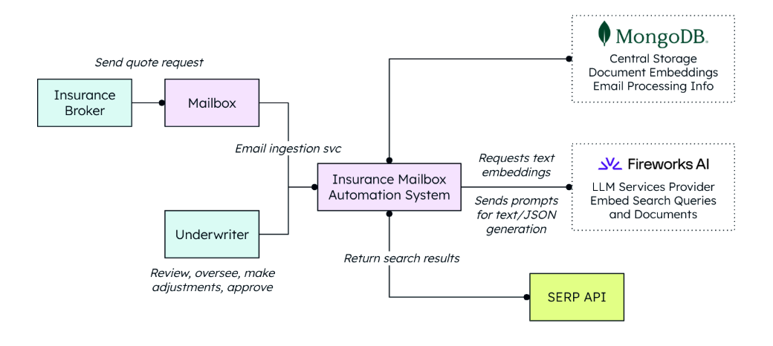

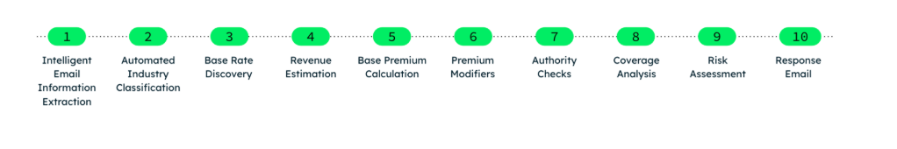
Real-world application: A quote request journey
Let’s follow a typical quote request through the system to see the technology in action. This example demonstrates key steps from the 10-step AI pipeline described earlier in the chapter, focusing on the most critical processes to illustrate how the system handles real-world scenarios.

Let’s begin with the email that kickstarts the whole process:

Subject: Quote Request - ABC Construction Corp
Hi there,
I need a quote for ABC Construction Corp. They're a mid-size commercial
construction company based in Texas, doing about $15M in annual revenue.
They need General Liability coverage with $2M/$4M limits, plus Auto
Liability for their fleet of 25 vehicles.
The company has been in business for 12 years, 85 employees. They've had
two small workers comp claims in the past 3 years but nothing major.
They're looking for coverage to start March 1st.
This is somewhat urgent; they're shopping around and want to make a
decision by end of week.
Thanks,
Sarah Johnson
ABC Insurance Brokerage

This email contains all the essential data points the AI system needs to generate an accurate quote, though they’re embedded in natural, conversational language. Notice how the email clearly states the company’s annual revenue ($15M), employee count (85), specific coverage requirements (General Liability with $2M/$4M limits plus Auto Liability), and fleet size (25 vehicles). The AI will also extract critical risk indicators such as the company’s 12-year operating history and loss experience (two small workers’ comp claims), plus operational details such as the Texas location and March 1st effective date. Even subtle cues, such as somewhat urgent and end of week for the decision timeline, help the system prioritize this request appropriately.

Now, we’ll follow the step-by-step processing with Fireworks and MongoDB to see exactly how the AI transforms this unstructured email into actionable underwriting data, using the same pipeline steps we outlined earlier:

Intelligent email information extraction: NLP extracts structured information from unstructured broker communications, identifying client details, coverage requirements, and urgency indicators with high accuracy. In Sarah’s email, the AI identifies ABC Construction Corp as the client name, parses $15M in annual revenue into a numerical value, and extracts specific coverage needs from phrases such as General Liability coverage with $2M/$4M limits, plus Auto Liability for their fleet of 25 vehicles.
Automated industry classification: Semantic search (vector search) through BIC code databases determines precise industry categorization by matching company descriptions with standardized classification systems.
Base rate discovery: Vector search retrieves industry-specific base rates from rating manuals, ensuring accurate foundational pricing based on established underwriting guidelines. Using the determined BIC code of 44 for construction, the system retrieves the specific base rate of $8.50 per $1,000 of revenue that applies to ABC Construction Corp’s general liability coverage:
Risk assessment: It analyzes risk factors through document retrieval and AI reasoning. The AI specifically processes Sarah’s mention of two small workers’ comp claims in the past 3 years and the company’s 12-year operating history to determine risk modifiers.

Response email/quote generation: The final step is producing a comprehensive quote with full documentation and professional formatting. The final quote directly addresses Sarah’s timeline (end of week) and incorporates all the specific details from her email (the March 1st start date, the exact coverage limits requested, and the fleet size) into a professional response.
Subject: Quote for ABC Construction Corp - General Liability Coverage
Dear Sarah,
Thank you for your quote request for ABC Construction Corp. We're pleased to provide the following quote:
**Coverage Summary:**
- General Liability: $2,000,000 / $4,000,000
- Auto Liability: $1,000,000 Combined Single Limit
- Effective Date: March 1, 2024
**Premium Calculation:**
- Base Premium (GL): $127,500
(Based on $15M revenue × $8.50 per $1000 - BIC Code 44)
- Loss History Modifier: +15% ($19,125)
- Auto Liability Premium: $18,750 (25 vehicles × $750 base rate)
- **Total Annual Premium: $165,375**
**Underwriting Notes:**
- Previous workers compensation claims reviewed and factored into pricing
- Construction operations fall within our standard appetite
- No additional endorsements required for this risk profile
This quote is valid for 30 days. Please let me know if you need any
modifications or have questions.
Best regards,
Automated Underwriting System

